Software Requirements Specification
For
Organic Dairy Farming- ERP System
Version 1.0 approved
Prepared by Aman Jain

NIIT University
Date: 12/09/2016

Introduction

Purpose
The purpose of this document is to present a detailed description of the Organic Dairy Farming ERP system. It will explain the purpose and features of the system, the interfaces of the system, what the system will do, the constraints under which it must operate and how the system will react to external stimuli. This document is intended for both the stakeholders and the developers of the system.

Intended Audience and Reading Suggestions
This ERP system is intended for the company owner, the admin, the developers, marketing staff, users, customers and other stakeholders. This SRS explains the designing and functionality of the software.

Product Scope
Organic Dairy Farming is an ERP system that aims at making an overall solution for an owner of an dairy farm, by providing him with an interface with pertains to each and every field of his venture, thereby reducing his time in managing each of them individually by manually writing them down on various physical media. By using this system the owner is freed from the worry of managing all his data by stacking them together, he just needs to type in the data and it is automatically linked to the respective field. It also provides easy accessibility for all those owner who have multiple farms to manage or are away from their farms but still want to have an update on what going on, by making all his data available on the cloud to be access from anywhere on the go.

Overall Description

Product Perspective
Our product Organic Dairy Farming is an ERP database which is a new self-contained product in itself. The product is not dependent on any other software for its seamless execution.

Product Functions
The ERP model has various product functions, some of which are listed below:

- Data entry into the database by the admin and other employees. There are many fields into which the data can be added and recorded into, they are listed below:
- Cattle: Maintains the record and data of each and every cattle of the farm. It includes there tag number, breed, weight, natural cycle, artificial insemination, important dates, diet, and other details.
- Fodder: Maintains the record and data of every type of fodder used for the cattle. It includes fodder statistics, nutrient level, composition, production favorable season, added substituents, and how they affect the cattle.
- User Data (Know Your Customer): It include the name, contact details, e-mail ID, payment details, purchase type and other relevant information.

- Sale of dairy products: Maintains a record for the daily sale of various product, which will help to provide a forecast for the admin to make future plans.
- View the current status of the cattle: Provides information about the cattle which need to have to be looked after.
- Alert system: Shows important and critical alerts about the overall farm which need immediate attention of the admin and the employees.

User Classes and Characteristics
The product is mostly aimed to be used by the Product or the Farm Owner (Admin) and Employees to update the day to day report and to make the necessary chances in the database for the overall view of the task assigned to each person. Secondly user will be the Customers of the Dairy Products who intent to purchase them.

Operating Environment
The product is compatible with every HTTP supporting browsers which includes Google Chrome, Safari, Mozilla Firefox, IE, Netscape, and many more. It is developed keeping in mind the user and hence is compatible with desktops, laptops, other personal computers and tablets, which enable the user to freely access the data as per his wish. There are no restrictions on the operation system that the user wants to use, the product is compatible with: Windows XP and above, iOS and Linux (Ubuntu).

Design and Implementation Constraints
The product is made to work with the minimalistic system, there are no such restrictions and constrains on the product usability. Some of the preferred requirements for a smooth processing of the software are:

Memory limitations: 30 Mb (approx.)
Languages used for developer reference are: HTML, CSS (Bootstrap), JavaScript for frontend and Python with Django framework for backend.
Database in used for the product: MySQL (open source)

User Documentation
The product users will be provided a user manual that will be delivered along with the software, to help and facilitate the user experience while using this product.

Assumptions and Dependencies
The product has no dependencies as such on any other product services. Although the users of this software must have internet access to the device there are using to access it with, which must be enabled with HTTP communication services supporting browsers.

External Interface Requirements

User Interfaces
- The index page of the ERP portal is a login page that directs the user to the main system page. An error will be displayed if the login is unauthorized.
- In the main system page, there will be a navigation bar which will have options of search and logout.
- There will also be a vertical navigation bar with certain options which are
  - Database, which when chosen, will direct to another page.
  - Create more users, where the accessibility rights will be given to the employees.
- On the right side of the page, there will be a section for daily updates and emergency alerts, along with an option to add or edit them. There will also be a reminder system that will automatically add certain required updates here.
- In the database page, the navigation bar on the left side of the page will contain the list of various databases which are
  - Cattle database – It will have set of information such as cattle id, name, breed, age, sex, etc.
  - Fodder database – The various fields here will be type of seed, fertilizers used, irrigation, harvest, etc.
  - Customer database – Here, the data on each and every customer will be stored. The data will include customer id, name, address, contact info, purchase info, etc.
- Each and every field can be updated by the admin. The options available to the other users will be decided by the admin.
- The product store will have a navigation bar at the top which will have search, signup and login.
- The page will have a list of all the available products along with add to cart option.
- In the view cart section, there will be a checkout option, which can only be accessed after login, and will direct the customer to the payment portal.
- The payment receipts will be sent to the customers via email.

Here are some images of the user interface from the actual product for reference:

- Login page for admin and employees:



- Home page of the admin with all the navigational tabs and notification panel.
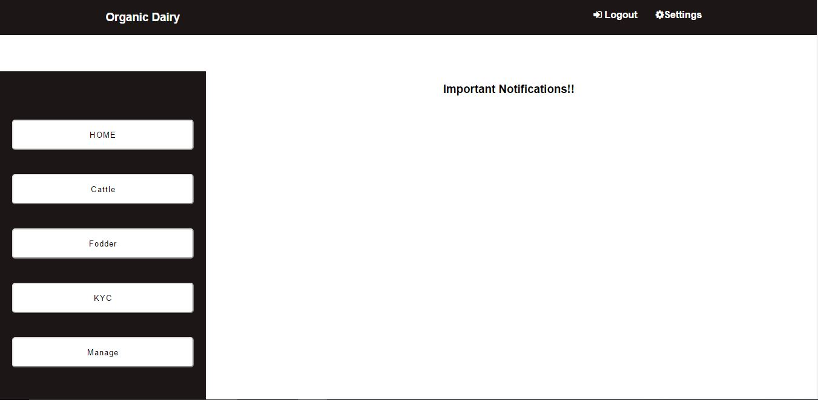

Hardware Interfaces
The product is compatible with every HTTP supporting browsers which includes Google Chrome, Safari, Mozilla Firefox, IE, Netscape, and many more. It is developed keeping in mind the user and hence is compatible with desktops, laptops, other personal computers and tablets, which enable the user to freely access the data as per his wish.

Software Interfaces
The Product uses a Database system (MySQL) for storing the Cattle, Fodder and Customer information in a systematic way in suitable tables. The developers have used Python with Django web framework for developing the ERP website’s backend. The data is frequently updated by the employees in the fields and farm, which in turn can be viewed, updated, and edited by the owner or admin for rectification and other purposes.

Communications Interfaces
The product is using HTTP communication standard which a basic need in most software these days and hence there would not be any added cost for acquiring it

System Features

Requirement Identifier | Requirement Name | Description
REQ 1 | Login | Each user has to login with proper credentials to go to the Main Page
REQ 2 | Change password/Forgot Password | The user can change the current password by clicking on the option and verifying it via registered E-mail
REQ 3 | Add data to cattle database | Only Admin and authorized employees can add cattle info to the cattle database
REQ 4 | Add data to fodder database | Only Admin and authorized employees can add fodder info to the fodder database
REQ 5 | Add data to customer database | Allows Admin and authorized employees to add a customer's feedback
REQ 6 | View cattle data | Allows logged in users to view cattle info through the portal
REQ 7 | View fodder data | Allows logged in users to view fodder info through the portal
REQ 8 | View customer data | Allows logged in users to view customer info through the portal
REQ 9 | Add users | Gives admin the choice of adding new users and modifying the accessibility rights
REQ 10 | Alert System | Important Notifications will Be posted on the Main page like for Heat notification, Pregnancy due dates, Updates on sick Cattle
REQ 11 | Update cattle data | Allows Admin and authorized employees to update the existing cattle data
REQ 12 | Update fodder data | Allows Admin and authorized employees to update the existing fodder data
REQ 13 | Event Notification through calendars | Implement a color based notification through calendars, by marking important dates
REQ 14 | Update product store | Admin and authorized employees can update production info or add new products
REQ 15 | View products | Customers can view the products on the store page without sign in
REQ 16 | Add to cart | Customers can add products from the main page to cart
REQ 17 | Delete from Cart | Customer can delete the products form the cart if they don’t wish to purchase that product
REQ 18 | Sign up | Customers can sign up to the website which will help them to view their History of ordered products.
REQ 19 | Sign in | Customers can sign in to the website with proper credentials
REQ 20 | Update customer profile | Customer can update their profile by signing in to the account
REQ 21 | Checkout cart | Here, the customer can make their purchases after being signed in
REQ 22 | Payment Of the Product | The payment Will be done through the payment portal, after which a Receipt will be sent via E-mail.
REQ 23 | View Purchase history | Customer can view their purchase history after signing in to the website

Use-Case Diagram:
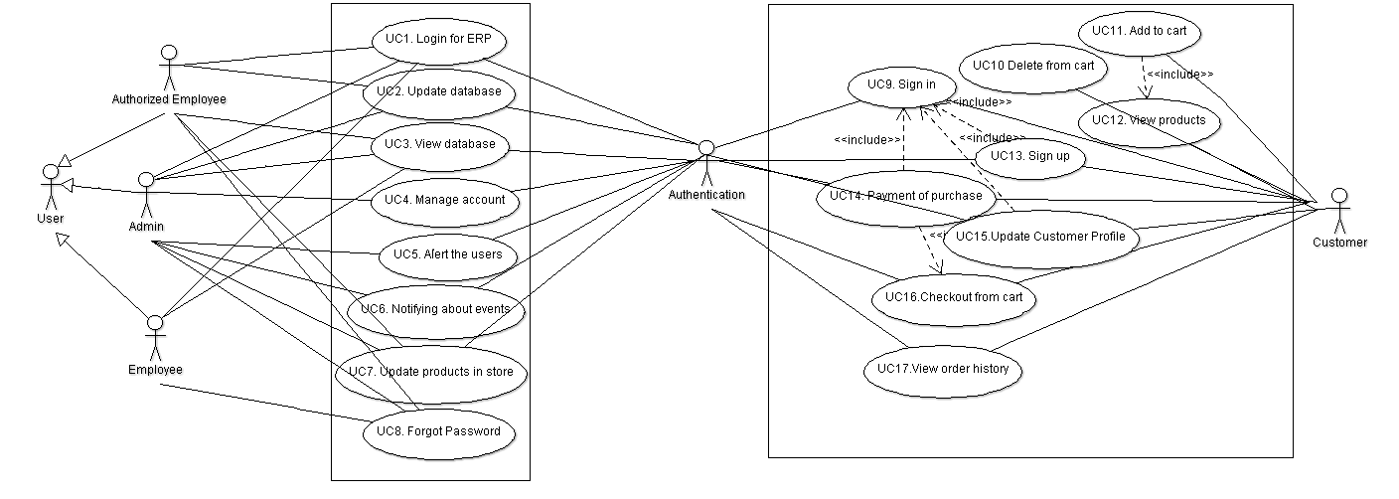

Other Nonfunctional Requirements

Requirement ID | Name | Description
N_REQ 5.1 | Performance requirement | Product should work in all conditions that to with minimal configuration, like slow internet etc
N_REQ 5.2 | Safety Requirements | Primary safety is to avoid unwanted uploads in to the database.
N_REQ 5.3 | Security Requirements | User cannot access the database without proper credentials and before the upload of data, it should be ensured it is free from any kind of malware
N_REQ 5.4 | Quality attributes- Adaptable | Our software adapts itself very efficiently, according to the circumstances
N_REQ 5.5 | Quality attributes- Correctness | Software always generates correct result
N_REQ 5.6 | Quality attributes- Availability | The product is easily available to the user via internet
N_REQ 5.7 | Quality attributes- Flexibility | It can be easily be modified with respect to future changes
N_REQ 5.8 | Quality attributes- Maintainability | With any future changes that has to be made, it won’t affect the architecture of the product
N_REQ 5.9 | Quality attributes- Testability | Developers can easily test the software
N_REQ 5.10 | Quality attributes- Usability | Users can be able to use the product very easily, with help of the user manual which will be provided along with the software

